Qair secures €37.9 million financing for Chad’s hybrid solar projects, demonstrating expertise in structuring complex energy investments

PRESS RELEASE

Paris & N’Djamena, 25 September 2026 – Independent renewable energy company Qair, today announces the first disbursement of a €37.9 million financing package for the construction of hybrid solar power plants with battery storage, totaling 30 MWp and 8 MWh, located in Gassi and Lamadji, Chad.

These projects were developed under a framework agreement with the Republic of Chad, paired with a 20-year Power Purchase Agreement (PPA) with Tchadelec, the national electricity utility.

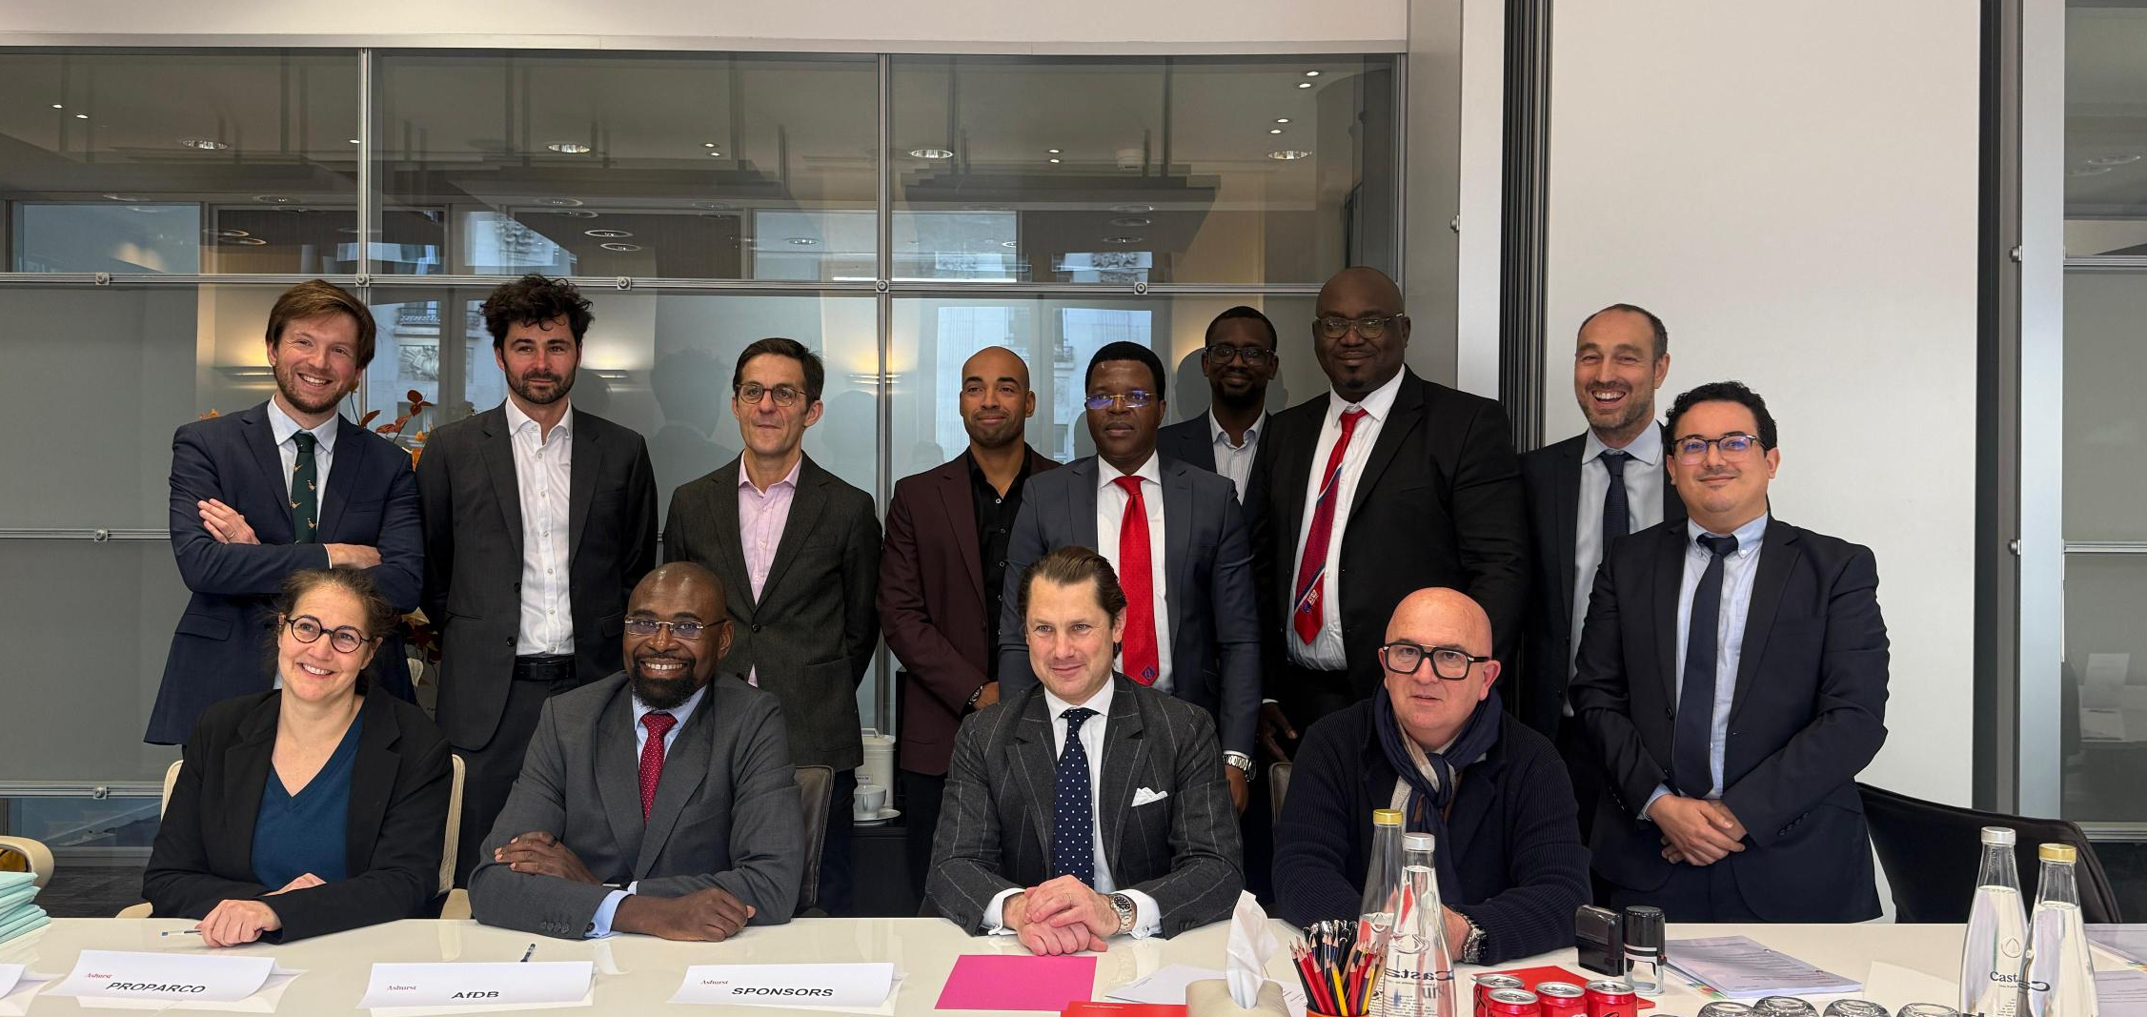
Scarlett Carré de Malberg (Proparco), Wale Shonibare (Banque africaine de développement), Louis Blanchard (Qair Group) et Marc Galinier (Qair Africa) entourés de leurs équipes.

Strategic partnerships for a robust financial structure
The financing was made possible through the commitment of key partners:
The African Development Bank (AfDB) and Proparco each provided €15.2 million in loans. Additionally, the Sustainable Energy Fund for Africa (SEFA), managed by AfDB, contributed €6 million in reimbursable grants, while Proparco / Agence Française de Développement added €1.5 million in supplementary funding. A Partial Risk Guarantee (PRG) of €8 million, issued by the African Development Fund (ADF) and the Green Climate Fund (GCF), strengthens the project’s financial structure by backing Coris Bank, the issuer of a letter of credit covering Tchadelec’s payments under the PPA. Coris Bank also serves as the onshore account bank and local security agent, while BNY acts as the offshore account bank, offshore security agent, and intercreditor agent.

A testament to Qair’s financial structuring capabilities
The Gassi and Lamadji projects highlight Qair’s ability to structure complex, multi-party financing solutions for high-impact renewable energy infrastructure. These projects underscore Qair’s expertise in navigating intricate financial landscapes, securing support from major development institutions, and delivering bankable projects in emerging markets.

« This financing demonstrates the strong confidence and collaboration between Qair, AfDB, Proparco, and SEFA in delivering impactful renewable energy infrastructure. The Gassi and Lamadji projects are a testament to our ability to structure and execute complex financing solutions, reinforcing Qair’s portfolio in Africa », said Abdoulaye Touré, CFO of Qair Africa.

About Qair in Africa

With over 15 years of presence on the continent and teams established across North, Central, and West Africa, as well as the Indian Ocean, Qair is a pioneering force in Africa’s renewable energy transition. Currently operating 85 MW of installed capacity, the group is developing a robust pipeline of over 2 GW spanning solar, wind, and hybrid technologies—aiming for 1 GW by 2030 and a leadership position in Africa’s energy transition.

By combining technical innovation with deep local engagement, Qair delivers clean, affordable, and reliable electricity while fostering local employment, training, and sustainable economic growth across the continent. Our projects are designed to address the unique challenges of each region, ensuring resilient and inclusive energy solutions that drive progress.

For more information, visit africa.qair.energy.

About Qair

Qair is an independent renewable energy company developing, financing, building, and operating solar, onshore and offshore wind, hydroelectric, tidal energy, renewable hydrogen production and storage projects.

With 1.7 GW of capacity in operation, the group’s 800 employees are developing an additional 30 GW pipeline in 20 countries across Europe, Latin America and Africa. Our ambition is to become an independent leader in responsible energy.
For media inquiries, please contact:
Media Relations: press@qair.energy | +33 (0)1 79 35 67 11

